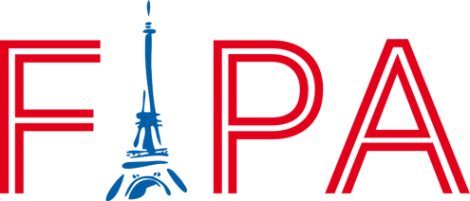

SCHOOL YEAR 2022 / 2023
EARLY BIRD MEMBERSHIP PRICES
Until August 1st, 2022

Register online www.fipamiami.org

Do everything online at www.fipamiami.org (you can pay in several installments)

Parent 1 name (first and last) _______________________________________________________________________
Parent 2 name (first and last) _______________________________________________________________________
Email___________________________________________________________________________________________
Contact phone number__________________________________________________________________________
Student information:
first name | last name | school | grade

- My company (or a company I know) might be interested in donating to this program

Membership | Reg. Price | Early bird Price | Total
Basic annual membership for one student in the French IS program (or as “friend of Fipa”) | $130 | $100
Family annual membership for one family with students enrolled in the French IS program  + t-shirt (according available sizes) | $250 | $200
Gold annual membership for one family with students enrolled in the French IS program  + two t-shirt (according available sizes) | $500 | $375
Platinum annual membership for one family with students enrolled in the French IS program  + one t-shirt (according available sizes) + two tickets to our Parents Night Out event + two tickets to our annual gala! | $1000 | $750

FIPA would like to welcome you to the French International Program. FIPA’s actions support the French International Studies Program in five Miami-Dade County Public Schools: Coconut Grove and Sunset Elementary schools, Carver Middle School, the International Studies Charter High School and Middle School (ISCHS) and the International Studies Preparatory Academy (ISPA). The program was created over 25 years ago and today is still unique within the United States because it offers an excellent French and American dual curriculum in a public-school setting.

You are now part of a unique community where the school staff, the Parent Teacher Association (PTA), and FIPA enhance your child’s education with many activities that provide cultural enrichment and reinforcement of core family, social, and individual values among other great benefits. We feel that even though we have amazing support from the Miami-Dade County Public School district, the schools would not be the exceptional schools it is if it weren’t for our families’ support and involvement in our efforts. Thanks again for your support!

With your membership, FIPA will be able to enrich the French IS program in many ways, and consequently, the quality of French education your child receives.

For more information about FIPA, our memberships, or anything else, please feel free to contact your current FIPA Liaisons,

ischs@fipamiami.org
carver@fipamiami.org
sunset@fipamiami.org
ispa@fipamiami.org
cge@fipamiami.org

Sincerely,
Your FIPA Board
fipa@fipamiami.org

FIPA is a non-profit organization: your donations are 100% tax deductible.

